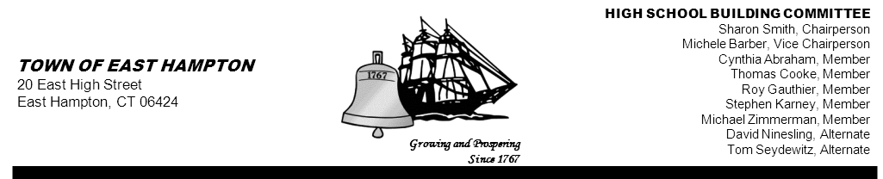

HIGH SCHOOL—ADDITION & RENOVATE-AS-NEW
HIGH SCHOOL BUILDING COMMITTEE MEETING
High School Library/Media Center
15 North Maple Street, East Hampton, CT 06424
Minutes
Thursday, May 16, 2013, 5:30 p.m.
PRESENT AT MEETING
Committee Members: Michele Barber, Vice Chairperson; Cynthia Abraham, Stephen Karney, David Ninesling, Tom Seydewitz, Thomas Cooke, Roy Gauthier, and Michael Zimmerman

Member(s) Absent: Sharon Smith, Chairperson; and Keith Klemonski, Parent Liaison

Also Present: John Mena, Division Director CREC; Glenn Gollenberg, Principal In Charge SLAM; Amy Samuelson, AIA SLAM;
Michael MacDonald, NCARB Downs Construction; John Fidler, High School Principal; Mark Winzler, Interim Superintendent; and Michael Maniscalco, Town Manager

1. Call to Order
The meeting was called to order by Vice Chairperson Michele Barber at 5:33 p.m.

2. Public Remarks
None

3. Review and Approve Minutes from May 2, 2013
MOTION: By Stephen Karney and seconded by Cynthia Abraham,
to approve the 05-02-13 minutes as written
Vote (7-0-1) Michael Zimmerman abstained due to not being present at that meeting.

4. Action Items:
- Approval of Invoices
There were no invoices to approve at this time.

5. Reports and Discussion:
- Referendum Update
Glenn Gollenberg and Amy Samuelson presented an outline of the presentation to be shown at the public informational meetings
on Friday May 17th at the Town Library and Tuesday, May 21st at the EHHS Library (immediately following the town meeting).

SLAM’s presentation included blue text boxes on each PowerPoint slide responding to specific comments from the 2007 NEASC report. This idea was favorably accepted by the committee.

A discussion took place regarding the importance of what the NEASC report represents and educating the public as to “WHY” the
entire building is being renovated.

The presentation included safety and security features as well as the areas available for community use. In addition, the slide of a cross section of the interior was important, as it points out inefficiencies of the current building. Also discussed, was the financial impact of the project to the tax payers and potential increase in property value.
It was suggested that the referendum date be displayed on the screen during the Q&A session of the public informational meetings.

- Communication Update
Michele Barber reported that every Friday she will forward any information that she receives during the week, to the committee.

A discussion took place regarding the process of handling change orders /approving invoices.

Michael Maniscalco noted that the Town Council has not given him the authority to sign change orders at this time.

Michael McDonald explained the process and importance of logging in each change order and how they are tracked. More to be discussed in future meetings.

Cynthia Abraham reminded the committee of the tri-board meeting planned after the referendum and would include discussion of the issue of change orders and invoices.

- Schedule Update
Tuesday, May 21, 2013, 7 p.m. Town Meeting, EHHS
Tuesday, May 21, 2013, 7:15 p.m. HSBC Public Forum Meeting, EHHS
Thursday, May 30, 2013, 5:30 p.m. HSBC Meeting, EHHS
Tuesday, June 4, 2013, 6 a.m. to 8p.m. Referendum, EHHS

- Project Management Update
John Mena discussed the Budget Report and distributed a copy for the committee’s review ( attached below).

Roy Gauthier noted that the report did not have a date and that he would like to see a date on each report. Mr. Mena agreed to have a date on the reports going forward. Mr. Gauthier also noted that there where outstanding items that have not been paid and explained how interest may be charged if they are not approved in a timely manner. Michele Barber noted that not all invoices have been submitted for payment as yet.

6. Chairperson’s Report
Michele Barber noted that Sharon Smith is vacationing this week and, hopefully, she will be back for the next meeting.

A discussion took place as to whether the public informational meeting, to be held Tuesday, May 21st, should be put on the agenda as a Building Committee meeting. It was suggested by Mr. Maniscalco to put the meeting on the agenda.

7. Public Remarks
John Fidler inquired as to the setup of the equipment, i.e. the screen, in the library room for the back-to-back meetings. A discussion took place as to what was best for both meetings.

8. Adjournment
MOTION: By Stephen karney, seconded by Michael Zimmerman
to adjourn the meeting at 7:34p.m.
Motion unanimously carried

Respectfully submitted,

Priscilla Ulm
Recording Secretary

Attachment below



